

University Network Using Cisco Packet Tracer

Submitted by:
Muhammad Abubakar
F2022266810

Program: BS in Computer Science
Submitted to:
Course Instructor: DR.Bilal Ashfaq

A Project submitted in partial fulfillment of the requirements for the degree of bachelors of Science in Computer Science

Department of School And System Technology
University Of Management & Technology Lahore, Pakistan.

Declaration

I declare that the project report University Network Using Cisco Packet Tracer is based on our own work carried out during the course of our study under the supervi- sion of Muhammad Rizwan.
I assert the statements made and conclusions drawn are an outcome of my research work. I further certify that

- The work contained in the report is original and has been done by us under the general supervision of my supervisor.
- The work has not been submitted to any other Institution for any other de- gree/diploma/certificate in this university or any other University of Pakistan or abroad.
- We have followed the guidelines provided by the university in writing the report.
- Whenever we have used materials (data, theoretical analysis, and text) from other sources, we have given due credit to them in the text of the report and giving their details in the references.

Dedication

First and foremost we offer our sincerest gratitude to our course instructor Muhammad Rizwan, who encouragement, guidance and support from the initial to the final level enabled us to develop an understanding of the subject. Without his guidance and persistent help this project would not have been possible.
To our parents, we would like to thank to them for supporting us in our daily lives, for going to school every day, and having them by our side to guide us always, their prosperity and love for us.

Acknowledgements

Thanks to ALLAH (s.w.t), the Greatest, the most Merciful and the most Gracious, Whose countless blessings bestowed upon me kind, talented and wise teachers, who provided me sufficient opportunities, and enlighten me towards this research work.
I would like to extend my deepest thanks to our project supervisors, Muhammad Rizwan for giving us the opportunity of undertaking this project under his determined directions. Their support, dedication, encouragement, excellent supervision and guidance are what made this thesis possible.
Thanks to my beloved family, whose prayers, dedication, support and love are the most precious assets, I had (and I have), during the course of my Computer Network work and for all of my endeavors.
I am very thankful to the administration and faculty of University Of Management & Technology, Lahore Campus for providing me a great environment that helped me a lot in conducting our project related activities.

Thank You!

Abstract
Computer network in the recent time has continued to evolve and has gone beyond just a collection of interconnected devices. Networking is a process of connecting computers, printers, routers etc. over a medium for the purpose of sharing informa- tion/resources. It is a very viable tool in the day-to-day running of an organisation. Research in data communication and networking has resulted in new technologies in which the goal is to be able to exchange data such as text, audio, video etc. Recently, no good establishment can effectively and efficiently work without a good computer network or internet [1].

Computer networks have a significant impact on the working of an organization. It participates not only on one side of life but in nearly every station, especially in ed- ucational organizations. The key aim of education is to share data and knowledge, making the network important for education. In particular, it is essential to ensure the exchange of information; thus, no one can corrupt it. To safe and trustworthy transfers between users, integrity and reliability are crucial questions in all data trans- fer problems [2].

University network is an important part of campus life and network security is essen- tial for a campus. Campus network faces challenges to address core issues of security which are governed by network architecture. Secured network protects an institution from security attacks associated with network.

Universities depend on the proper functioning and analysis of their networks for ed- ucation, administration, communication, e-library, automation, etc. An efficient net- work is essential to facilitate the systematic & cost-efficient transfer of information in an organization in the form of messages, files, and resources. The project provides insights into various concepts such as topology design, IP address configuration, and how to send information in the form of packets to the wireless networks of different areas of a University.

Therefore, we have developed a secure campus network (SCN) for sending and receiv- ing information among high-security end-users. We created a topology for a campus of multi networks and virtual local area networks (VLANs) using cisco packet tracer. We also introduced the most critical security configurations, the networking used in our architecture. We used a large number of protocols to protect and accommodate the users of the SCN scheme.

Contents
- Introduction 1
  - Objectives . . . . . . . . . . . . . . . . . . . . . . . . . . . . . . . . . 1
  - Introduction . . . . . . . . . . . . . . . . . . . . . . . . . . . . . . . . 1
  - Motivation . . . . . . . . . . . . . . . . . . . . . . . . . . . . . . . . . 2
  - Report Break Down . . . . . . . . . . . . . . . . . . . . . . . . . . . . 3
- Literature Review 4
  - Literature Review . . . . . . . . . . . . . . . . . . . . . . . . . . . . . 4
    - Network Topology . . . . . . . . . . . . . . . . . . . . . . . . 4
- Proposed Methodology 7
  - Block Diagram . . . . . . . . . . . . . . . . . . . . . . . . . . . . . . 8
  - Flow Chart . . . . . . . . . . . . . . . . . . . . . . . . . . . . . . . . 8
  - System Model . . . . . . . . . . . . . . . . . . . . . . . . . . . . . . . 9
  - Software Selection 10
- Simulation and Results 11
  - Simulation Results 11
    - Logical Topology 11
    - Statistical Analysis 12
    - Using Command Prompt 13
- Conclusion and Future Work 15
  - Conclusion 15
  - Future Work 15
Bibliography 16

Chapter 1 Introduction
This project is totally dedicated to the Network Engineer for new and smart learning of the Network Structure. In this concept it is possible for the networker to check the Network Structure of a company spread in the big campus area. The incoming and the outgoing traffic can be maintained along with some security concepts as well. In this logic we use the multiple Routing Protocols in different areas of the univer- sity. The practical shows us the proper movement of the packet from one part of the company to the other part of the company. The project comprises of the different departments spread in different buildings of the company. Multiple Routing proto- cols have been used in different branches and all the departments can communicate with other different departments through the Redistribution among different Routing Protocols.
The East Building has a DHCP server for assigning the IP Addresses to the Hosts in the building as well as a DHCP server has been used in the West Building as well. The Internet Service Provider has been used for Communication of the East and West Building with the Data Centre and Internet through ISP, using the Frame Relay Switching Technology available for Wide Area Network. Routing Protocols EIGRP along with the Synchronous Number, Static Routing, and its concepts including the Default Routing as well has been applied. The different Routing Protocols are running and which has been synchronized to work with Frame Relay Switching Technology.

Objectives
The objectives of this project are:
    - To get familiar with how to established a network for any company.
    - To simulate the network using Cisco Packet Tracer.
    - To get familiar with networking protocols.

Introduction
Technology has reached its highest peak of development, especially in making life easier for people. Well implemented technology is faster than human in processing calculation and is more accurate. Technology has become an important concept in our life. It assists in connecting communities together. Obviously, people have started

to use technology in every field of life including education, health, the military, etc. The computer network represents a component, especially on how it enhances the functional performance in different fields and organizations, such as companies and schools.
A schools computer network performs so many functions, such as connecting stu- dents with the university, faculty, and the library. Most universities today use the network to provide online education by connecting widely dispersed students with their professors directly.
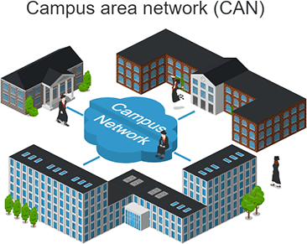

Figure 1.1: A Campus Network

For this reason, computer networks play a vital role in the education area by provid- ing efficient communications for the university environment. However, the design of computer networks differs from one university to another. This is as a result of many factors which determine the differences. Such factors include; adaptability, integra- tion, resilience, security, and cost. Installing networks in a university relies on the universitys budget, which differs by institution and from country to country.
For instance, there are many countries whose universities do not have the financial capability for designing the perfect or ideal network. Yet these universities from these third world countries still need to have good quality and more secure network equipment with less cost. This is because these schools aspire to deliver capability in line with the leading prestigious universities despite low budgets.

Motivation
The word digital is very significant in todays world, with an increase in the de- velopment of technology the entire world is moving towards the digital era. The educational institution plays an important role in this digitalization, hence the cam- pus should adapt to digital means of networking as well and become a digital campus.
Campus networking becomes an important part of campus life and provides the main way for teachers and students to access educational resources, which gives an

important platform to exchange information. As laptops and intelligent terminals are widely used, demand for access to information anytime and anywhere has become more and more urgent. Campus network provides an efficient way to explore the internet with a mobile terminal for teachers and students. This is an important mark of the modern campus. With the development of network and communication tech- nology, cable networks on a university campus bring much convenience for teaching and research work.

Report Break Down
The major focus of this report is on the findings of the proposed project i.e. University Network using Cisco Packet Tracer.
This Report is organized as follows:
In chapter 2, literature review is provided in detail about the work which is already been done on Network using Cisco Packet Tracer and will give a brief details about the articles, papers and literature review.
In Chapter 3, Proposed Methodology is presented in which you will be able to see the method we will work on the designing of a complete project source code to the diagrams.
In Chapter 4, Result and Simulations are being discussed, in which you will see all kind of finding related to the Campus Network using Cisco Packet Tracer.
In Chapter 5, we have concluded and summarized the project work and also presented few new research ideas for future studies.

Chapter 2 Literature Review
In the chapter 1 we have given the introduction of our project, objectives and a thesis break down. Our introduction chapter is giving a complete overview of this project report. This chapter is about the work which is already been done on University Network using Cisco Packet Tracer, and will give a brief details about the articles, papers and literature review.

Literature Review
This chapter is about studies and literatures that are related to the University Net- work using Cisco Packet Tracer that the proponents made use of different reading materials (such as thesis, articles, and other web articles) that will help extending the knowledge of the topic. These reading materials will also guide the proponent to improve and develop their proposed system more effectively.

Network Topology
A network topology defines how hosts are connected to a computer network. It characterizes how the PCs and other hosts are organized, and linked to each other.

Point to Point Topology
Point to Point topologies connect two computers together with a single line connec- tion. The advantage of Point to Point Topology is that it gives a faster connection, and it is also less expensive than other topologies. The strength of this topology is more than other kinds of connection[3].

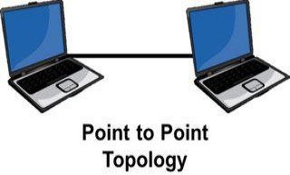

Figure 2.1: Point to Point Topology

Bus Topology
Bus topology, with the inexpensive configuration, many computers are connected by a single line of cable. Each side of the main cable must be connected to terminals. This type of network topology is small and very easy to connect devices together to making the network. The bus topology uses one main cable for all the connection, and its usually seen in smaller networks. If the main cable is broken, there will be a network failure such as that seen at a local office level[4].

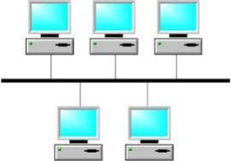

Figure 2.2: Bus Topology

Ring Topology
Another topology is the ring topology, which uses a connecting computer in a circle shape. The source computer sends information to the cable ring, and this information searches for its destination by accessing each computer on the ring until it gets its destination node. According to the article “A review of Network Topology” by Jiang, Adjacent pairs of workstations are directly connected. Other pairs of workstations are indirectly connected, the data passing through one or more intermediate nodes [5].”
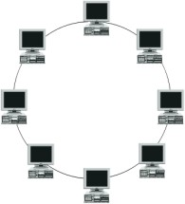

Figure 2.3: Ring Topology

Mesh Topology
The mesh topology requires each computer to be connected directly to multiple com- puters, with more than one line connecting all computers to each other. One good

thing about this topology is that if one line fails or cut, it will use the other paths to send information to the destination. This reduces the probability of a total network failure. Mesh topology is faster compared to other kinds of topology, but it is very expensive. According to the Clarke “A disadvantage of a mesh topology is the cost of the additional cabling and network interfaces to create the multiple pathways be- tween each system [6].“

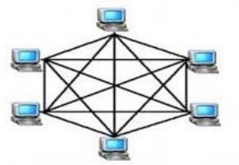

Figure 2.4: Mesh Topology

Star Topology
The star topology is generally used for all networks whereby each device or computer is connected to a center hub by a direct line. The center hub can be a switch, router, or server. Each computer connects directly to the center device such as the hub, router, and server. “A star topology is designed with each node connected directly to a central network hub, switch, or concentrator [5].” It is easy to add and remove a computer from the network without affecting the network. Pandya, Kartik mentioned in their article, “It is easy to replace, install or remove hosts or other devices, the problem can be easily detected-It is easier to modify or add a new computer without disturbing the rest of the network by simply running a new line from the computer to the central location and plugging it to the hub [4].”

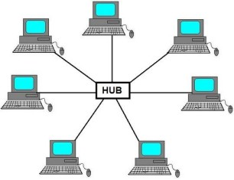

Figure 2.5: Star Topology

Chapter 3
Proposed Methodology

In the previous chapter, we have discussed the theories that support this research related to the University Network using Cisco Packet Tracer. In this chapter we will proposed our methodology for this project.
Basically we are following the given below question step by step.
UMT University is a large university which has 4 main buildings situated apart. The university’s students and staff are distributed in 4 departments: these includes the Department of Computer Science, Department of Mathematics, Department of Electrical and Computer Engineering, & Admission Office.
Each member of staff has a PC and students have access to PCs in the labs.
Requirements

- Create a network topology with the main components to support the following:
  - Building A: Department of Computer Science is distributed in the building offices for the faculty, and labs. It is expected that they will share networking equipment (Hint: use of VLANs is expected here)
  - Building B: Department of Mathematics including offices, lecture hall- s/lecture rooms.
  - Building C: Admission office distributed in different offices.
  - There is also an email server hosted externally on the cloud.
  - Building D: Department of Electrical and Computer Engineering this can acts as a smaller campus as well as. It includes different offices and labs.
- You will be expected to configure the core devices and few end devices to pro- vide end-to-end connectivity and access to the internal servers and the external server.
  - Each department/faculty is expected to be on its own separate IP network
  - The switches should be configured with appropriate VLANs and security settings
  - RIPv2 will be used to provide routing for the routers in the internal net- work and static routing for the external server.

  - The devices in building A will be expected to acquire dynamic IP addresses from a router-based DHCP server

Block Diagram
Let us look at the detail block diagram in Figure 3.1, which illustrates the main components involved in University Network using Cisco Packet Tracer.
In this diagram, we have used:
    - 2911 Router, for the main campus network
    - 3650-24PS Multi Layer Switch, for different departments in the buildings
    - 2960-24TT Switches, for each department
    - A cloud router,
    - Servers, email server hosted externally on cloud, and a web server for IT de- partment
    - Host Devices, a PC and a printer
    - Wire, Serial DCE (HWIC-2T) for routers connections, Copper cross over for switches connections, and Copper straight through for the host devices connec- tions.

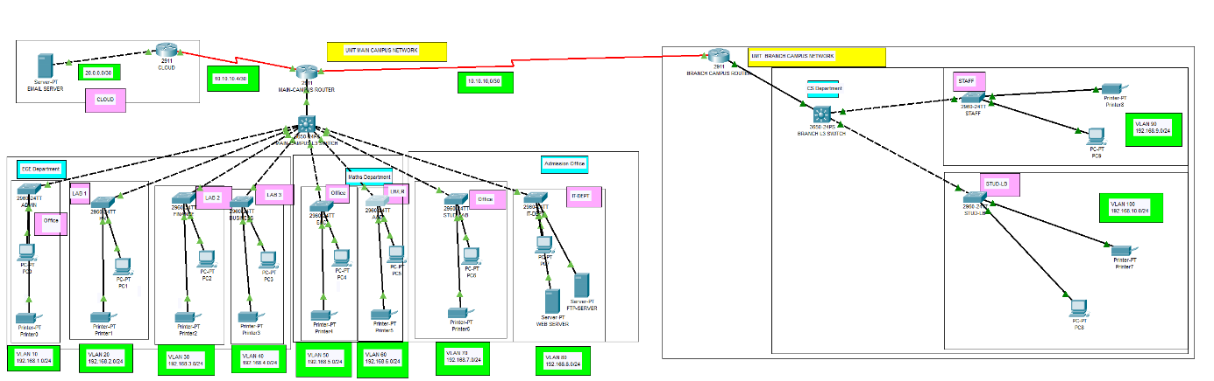
Figure 3.1: Block Diagram of University Network

Flow Chart
Figure 3.2 shows the flow chart of the University Network. Basically the main objec- tive of the project is the communication between different departments. To do so, we send message from one of the department’s pc to any other department’s pc or printer.
We will configure the network first, and than will check out if the IP of the next computer and our computer is working well. It will transfer our message packet to the destination host.

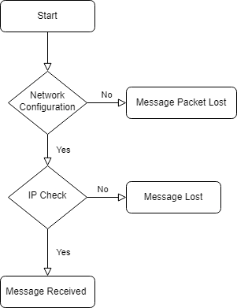
Figure 3.2: Flow Chart of University Network

System Model
A large campus with groups of buildings can also use WAN technology to connect the buildings as shown in the Fig. 3.3. Although the wiring and protocols of a campus might be based on WAN technology, they do not share the WAN constraint of the high cost of bandwidth. After the wire is installed, bandwidth is inexpensive because the company owns the wires and there is no recurring cost to a service provider. However, upgrading the physical wiring can be expensive.
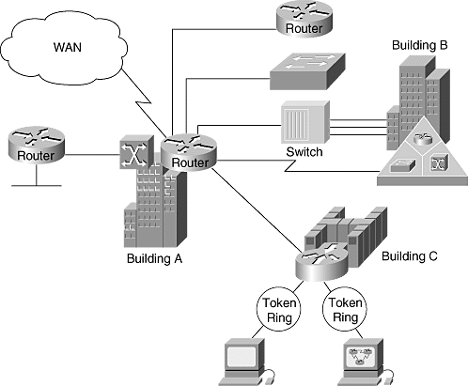
Figure 3.3: System Model of University Network

Software Selection
We will simulate our campus network using Cisco Packet Tracer Version: 7.3.0.0838. Cisco Packet Tracer is a powerful network simulator for CCNATM and CCNPTM certification exam training allowing students to create networks with an almost un- limited number of devices and to experience troubleshooting without having to buy real CiscoTM routers or switches.
Cisco Packet Tracer features an array of simulated routing & switching protocols with STP, HSRP, RIP, OSPF, EIGRP, and BGP to the extent required by the cur- rent Cisco CCNA curriculum as well as application layer protocols (HTTP, DNS, ) to simulate network trafic .
It also includes Cisco IOS 15 with licence features, wireless capabilities with WLC and lightweight access point, security devices with ASA 5505 and 5506-X firewalls, and SDN controller.
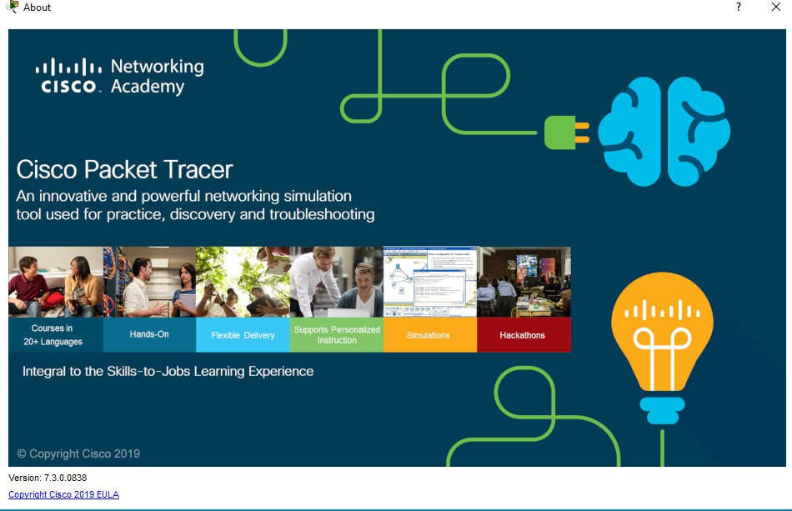
Figure 3.4: Cisco Packet Tracer

Note: You can simulate this network on any latest version as well as.

Chapter 4
Simulation and Results

In the previous chapter, we have discussed about our methodology for this project while giving details about block diagram, system model, flow chart, software selection of this project. In this chapter, we will provide the viewable logical topology, and results of the project.

Simulation Results
As discussed in the previous chapter in the section of software selection, we have used Cisco Packet Tracer to simulate our project.

Logical Topology
In the Fig. 4.1 a main branch topology is shown which contain three departments, Electrical and Computer Engineering Department, Mathematics Department, Admission Department, and a Cloud Server.

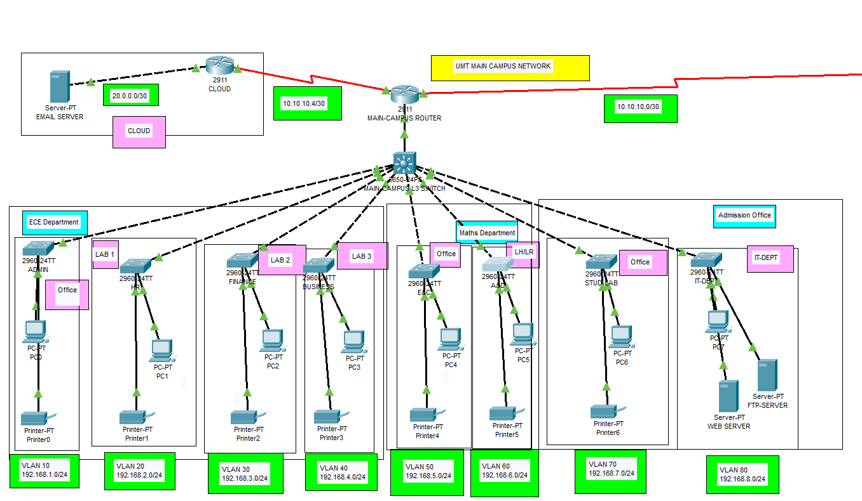

Figure 4.1: Main Branch Topology

Whereas in Fig. 4.2, department of Computer Science is shown which contains different offices and lab. The reason we called this UMT Branch Campus is because it is quite apart from the other department in this case we can consider this as a Branch Campus. We can include this in the main branch too but the reason of treating this as a campus is to learn how to connect campus network with the main network.

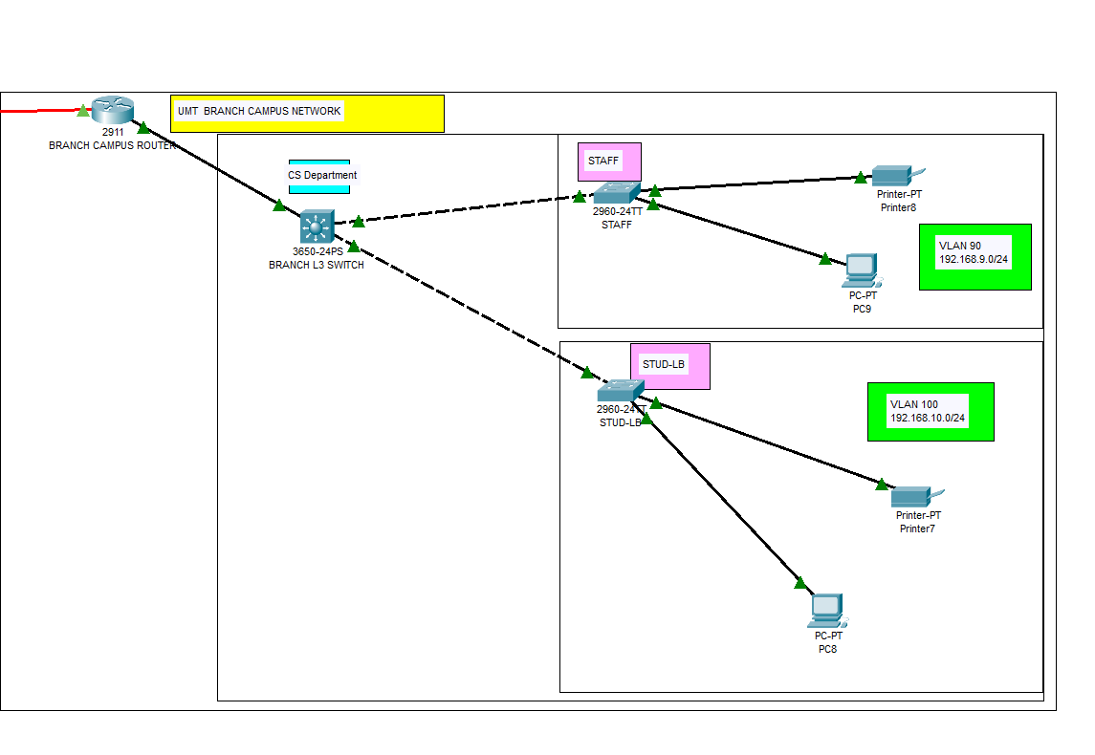

Figure 4.2: Branch Topology of CS Department

Statistical Analysis
Fig. 4.3 shows the results of the simulation. In which, we have forwarded a message from source host i.e., PC0 to the destination host i.e., PC4.

Figure 4.3: Simulation Results

Fig. 4.4 it’s showing a complete path which it follows to reach to the destination host and than acknowledge back to the source host with the time it take while using Internet Control Message Protocol (ICMP) which is a network layer protocol used by network devices to communicate.

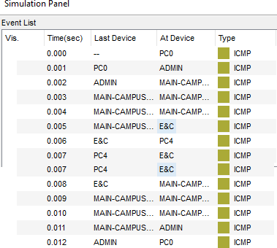

Figure 4.4: Simulation Panel Results

Using Command Prompt
The ping command is a very common method for troubleshooting the accessibility of devices. It uses a series of Internet Control Message Protocol (ICMP) Echo messages to determine:

      - Whether a remote host is active or inactive.
      - The round-trip delay in communicating with the host.
      - Packet loss.
The ping command first sends an echo request packet to an address, then waits for a reply. The ping is successful only if:
      - the echo request gets to the destination, and
      - the destination is able to get an echo reply back to the source within a predeter- mined time called a timeout. The default value of this timeout is two seconds on Cisco routers.
Fig. 4.5 shows a different way to check if our network connectivity is reliable. We have used command prompt of PC2 and have ping two hosts: one from the branch/CS Department host i.e, PC8 with IP address 192.168.10.2/24 and second from Admission Department host’s i.e., PC6 with IP address 192.168.7.2/24.

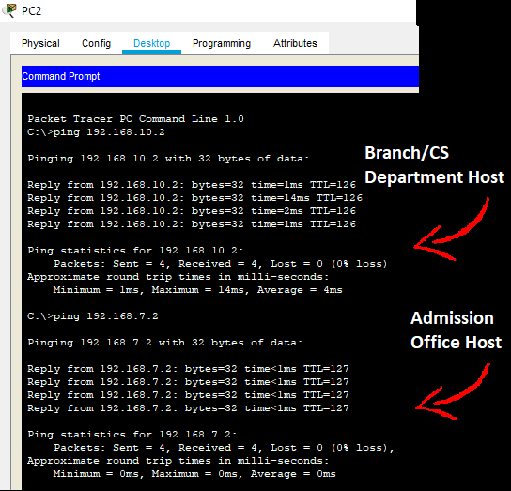
Figure 4.5: Command Prompt Results

Chapter 5
Conclusion and Future Work

In the previous chapter, we have shown all the simulation and results of our proposed project. From introduction, Literature Review, Proposed Methodology, Result and Simulations. In this chapter, we will conclude our project and will

Conclusion
This work describes the University Of Management & Technology, Lahore Campus Network. We have:
    - Successfully simulated our topology using Cisco Packet Tracer.
    - Learned basic knowledge of how department communicate with each other in any organization.
    - Discussed a real life university scenario. In this project, we have done following tasks:
      - Planned, designed, and prototyped the network topology for our university i.e., University Of Management & Technology, Lahore Campus.
      - Configured the network in Cisco Packet Tracer with appropriate settings to acheive the connectivity and functionalities.

Future Work
For future work, we recommend the Following things:
    - Practical implementation of the network.
    - Work on the security of the network.
    - Can simulate the network on any other simulation software.
    - Can work on the accuracy and time of the received signal.

Bibliography

- L. Ezema, W. Mbonu, U. Nwogu, and C. Owuamanam, “Plan, design and sim- ulation of university network,” International Journal of Advanced Computer Re- search, vol. 4, no. 3, p. 834, 2014.
- A. H. Ahmed and M. Al-Hamadani, “Designing a secure campus network and sim- ulating it using cisco packet tracer,” Indonesian Journal of Electrical Engineering and Computer Science, vol. 23, no. 1, pp. 479–489, 2021.
- P. Kornilovitch, R. Bicknell, and J. Yeo, “Fully-connected networks with local connections,” Applied Physics A, vol. 95, no. 4, pp. 999–1004, 2009.
- R. S. S. AlSarhan, “Computer network design for universities in developing coun- tries,” 2016.
- R. Jiang, “A review of network topology,” in 4th International Conference on Computer, Mechatronics, Control and Electronic Engineering, pp. 1167–1170, At- lantis Press, 2015.
- G. E. Clarke, CompTIA Network+ Certification Study Guide. McGraw-Hill, 2009.

